low-value care Visualizer
User Guide V.1
January 2020

Table of Contents
1.0 Introduction 2
1.1 Purpose and scope 2
1.2 Points of contact 2
1.3 Glossary 2
2.0 Getting Started 3
2.1 Website 3
2.1 DATA input for manual entering 3
2.2 Upload functionality 6
3.0 Aggregate Results 7
3.1 % of low-value care 7
3.2 % of total service costs likely low value 7
3.3 Demographics 7
3.3 Stacked Bar Chart 7
4.0 Individual Results 9
4.1 Select service 9
4.2 Detailed description of results page functions 9
4.3 % of members receiving low-value care service 9
4.4 % of total service costs that is likely low-value care 9
4.5 Low-value care totals and trends 11
5 Summary i
6 Appendix A – Short Identifiers and Long Descriptions ii

Acknowledgments
Funding for the development of this free, open-source reporting tool has been received from PhRMA.

Introduction
This Guide contains all the information the user needs to make full use of the Low-Value Care Visualizer. This describes the Visualizer’s functions and capabilities and includes step-by-step procedures for system access and use.

Purpose and scope
The Low-Value Care Visualizer provides a standardized way to view low-value care information. This tool is not a calculator or estimator. Instead, it provides a visual display of claims data that have been synthesized, whether that is using internal resources or through one of the many low-value care estimators (e.g., PROMETHEUS Analytics, MedInsight Waste Calculator, Rowd Map, etc.) in the market. Regardless of the analytics used, this Visualizer will provide standardized visual displays of data, resulting in understandable interpretations of complex findings.

points of contact
If you have questions or need assistance, please contact:
Consortium Manager: Beth M. Beaudin-Seiler, PhD
3520 Green Court
Suite 300
Ann Arbor, MI 48105
Email: beth.beaudin-seiler@altarum.org
Phone: 734-302-5691

glossary
Proxy Unit Cost of Service – Because cost data often reflect the price charged instead of the price paid, they can be difficult to manage in a claims dataset. Therefore, a proxy cost, meaning a standard amount established by the claims developer, is used. If using raw data and are not using a claims estimator, the resulting cost data may be more closely aligned to actual prices and does not need to be referred to as a “proxy.”
Total Proxy Cost of Low-Value Services – Multiply the total number of low-value services by the proxy unit cost per service to calculate the total cost of low-value services. As noted above, if the data is raw data and has not been run through a claims estimator, it doesn’t need to be referenced as “proxy,” because it is more closely aligned with actual prices.

2.0 Getting Started

2.1 Website
The Low-Value Care Visualizer can be found at the following URL under the Resources tab and works best using Chrome or FireFox browsers: https://www.hcvalueassessment.org/resource-tool.php

2.2 upload functionality
The upload function enables the end user to download an excel template, fill in the data in the appropriate cells and then upload the file back to the Visualizer. Individual and Aggregate results will appear exactly in the same manner as the manual data entry. See Figure 1 for illustration.
STEP ONE: Download the excel workbook template.
STEP TWO: Enter the data into the workbook as outlined by the example. (Remove the example data prior to entering your data.)
STEP THREE: Browse for the file and select it.
STEP FOUR: Select Upload button.

Figure 1. Upload Functionality Illustration.
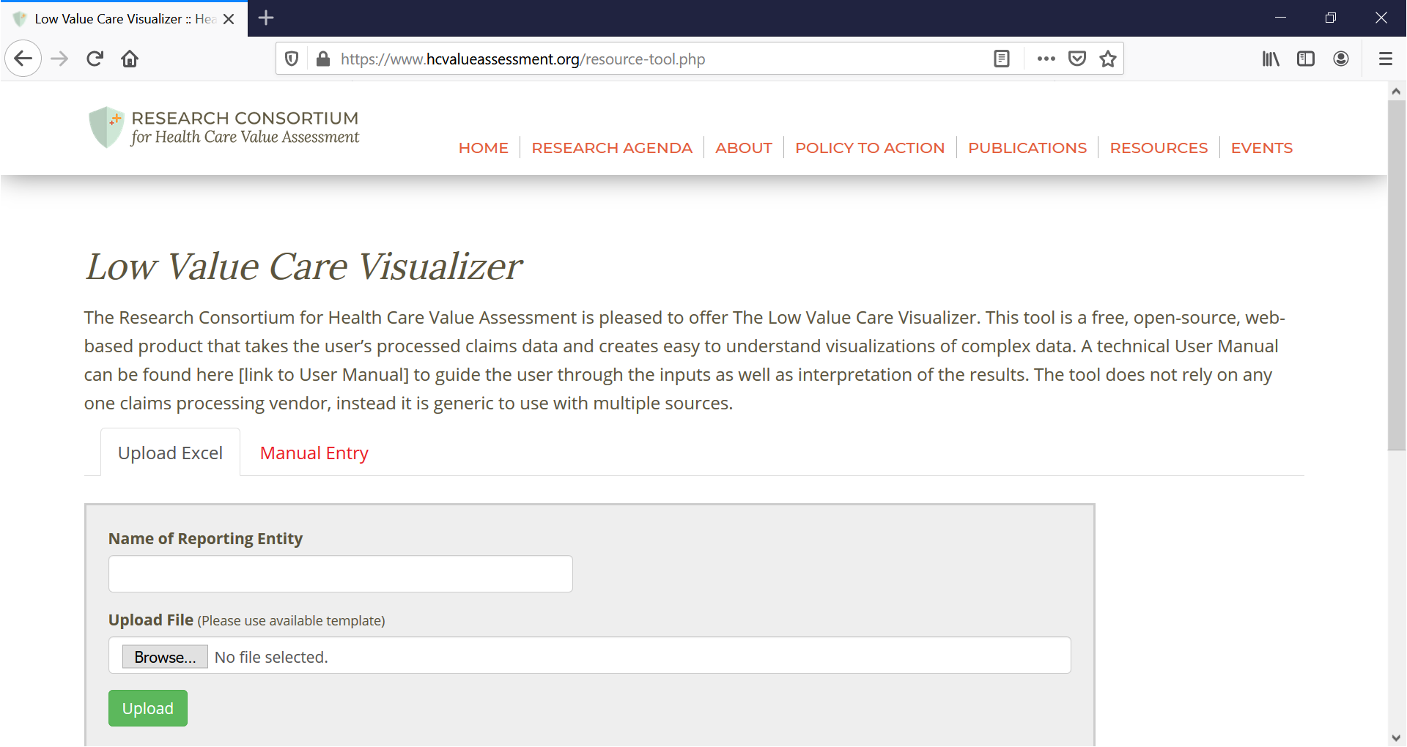

2.3 DATA input for manual entering
Figure 2 is a step-by-step illustration of where and how to input your data for visualization. The following instructions walk the user through entering data from processed claims into the appropriate data entry fields that are labeled Box 1, Box 2, etc.
STEP ONE: Enter Name of Reporting Entity into Box 1.
STEP TWO: Enter the Year of the claims data in Box 2.
STEP THREE: In Box 3, from the drop-down menu, select which Category of distinct low-value care service to visualize. If the desired service does not appear in the drop-down menu, select Custom Low-Value Care Service.
STEP FOUR: In Box 4, select the Distinct Low-Value Service from the drop-down menu.
STEP FIVE: In Box 5, enter the Total Number of Services.
STEP SIX: In Box 6, enter the Number of Low Value Care Services.
STEP FIVE: In Box 7, enter the Number of Members Who Received this Service.
STEP SIX: In Box 8, enter the Number of Members Who Received Low-Value Care for this Service.
STEP SEVEN: In Box 9, enter the Unit (Proxy) Cost of Service.
STEP EIGHT: In Box 10, enter the Total (Proxy) Cost of Services.
STEP NINE: Click on the Add Service button to add another service to the visualization. Repeat STEPS 3 through 8. As many services as are needed can be added.
Note: If you do not want to add a service, go to STEP TEN to add a year. If you do not want to add another year, skip to STEP ELEVEN to calculate your visuals.
STEP TEN: Click on the Add Year button to add another year to the visualization. You will only be allowed to examine the same Category and Distinct Low-Value Care Service(s) that you included in the first year. Repeat STEPS 3 through 8 for each of the Distinct Low-Value Care Service(s) included in the first year.
Repeat STEP TEN to add an additional year.
Note: If you do not want to add an additional year, move to STEP ELEVEN.
STEP ELEVEN: Click on the Calculate button.

Figure 2: Low-Value Care Visualizer: Input Page
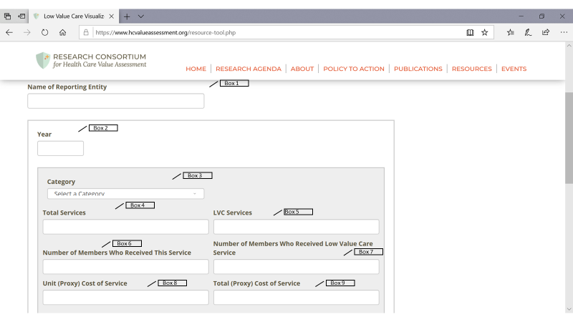

Aggregate Results
After clicking on Calculate or Upload, you will be redirected to the AGGREGATE RESULTS page. This page of the Low-Value Care Visualizer displays visuals for all reported services for all time periods entered on the main DATA INPUT page.

3.1 % of low-value care
This visualization shows the total percentage of members receiving any of the low-value care services entered on the main DATA INPUT page. See Figure 3, Box 1.

3.2 % of total service costs likely low value
This visualization displays the percentage of total overall costs that are attributed to likely low-value care, for all services entered on the main DATA INPUT page. See Figure 3, Box 2.

3.3 Demographics
The demographics Box on the AGGREGATE page shows information about the members of the dataset, including their total number, median age, gender by percentage, numbers by insurance type. See Figure 4, Box 3.

3.3 Bar Chart
The bar chart on the Aggregate Results page displays the top 5 costliest low-value care services. See Figure 4, Box 4. A cross-walk of the short identifiers and the long descriptions can be found at the end of this User Guide in Appendix A.

Figure 3. Low-Value Care Visualizer: Aggregate Page
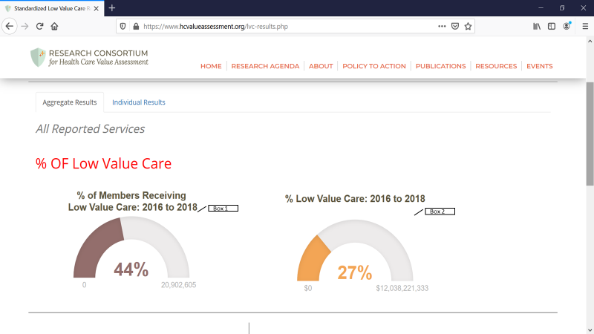

Figure 4. Low-Value Care Visualizer: Aggregate Page (Continued)
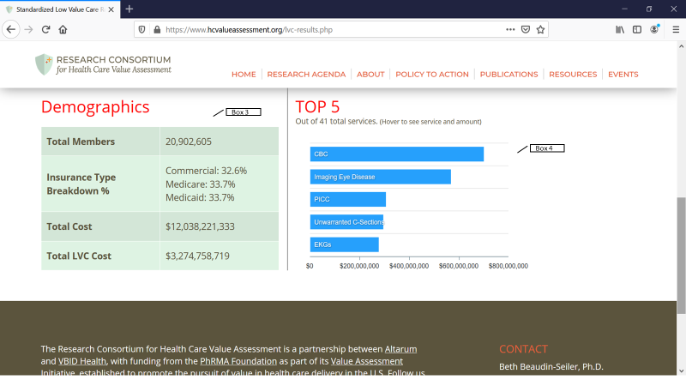

Individual Results

4.1 Select service
If the user has data for more than one service on the input screen, the individual results will be displayed on the INDIVIDUAL RESULTS page. Under Select Service, select which service to be visualized by clicking the drop-down menu. See Figure 5, Box 1.

4.2 detailed description of results page functions
The RESULTS page displays each individual service and the corresponding percentage of low-value care based on inputs from the main DATA INPUT page. Just below the name of the reporting entity, Figure 5, Box 2 shows a detailed description of the service.

% lvc dollars within selected service: 2016 to 2018
This graph provides a visual of the percentage of the low-value care dollars out of the total dollars spent on that specific service for all years entered on the main DATA INPUT page. See Figure 5, Box 3.

% of members with selected service that was low value: 2016 to 2018
This graph displays the members that have received that specific service and the percentage of them that were low value for all years entered on the main DATA INPUT page. See Figure 5, Box 4.

% of select lvc service contributing to total spend: 2016 to 2018
This graph shows the percentage of the specific service that is likely low value and how it contributes to the total spend. It includes all the years entered on the main DATA INPUT page. See Figure 5, Box 5.

Figure 5. Low-Value Care Visualizer: Results Page
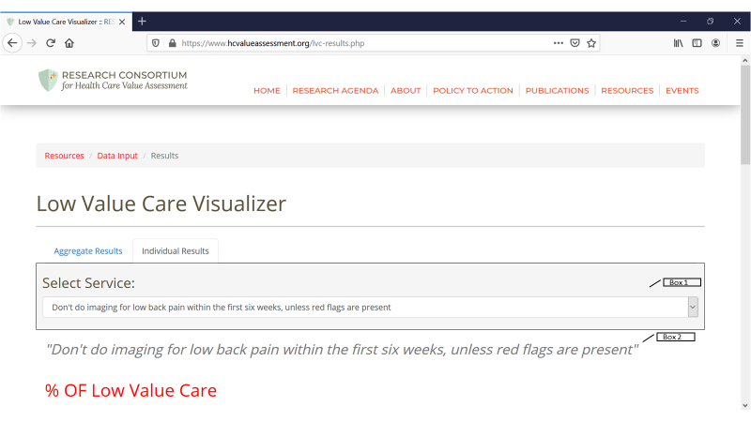
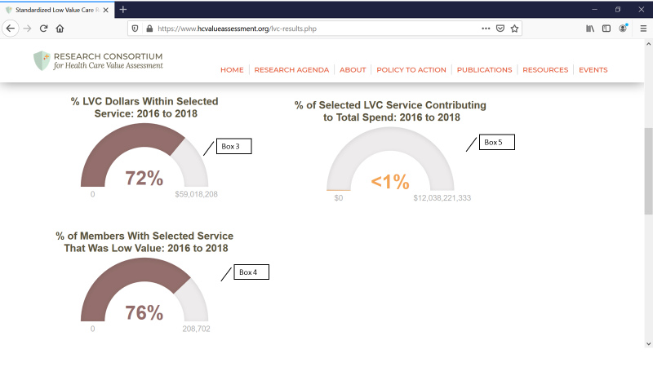

low-value care totals and trends
In Figure 6, Box 1 on the INDIVIDUAL RESULTS page, the user will see the total cost of the low-value service for all the years entered. Additionally, the user will see the total number of members who have received that specific low-value care service in Figure 5, Box 2.
Figure 6, Box 3 shows the trends graph, which identifies the trends for the years entered on the main DATA INPUT page for that specific low-value care service. The trends graph can be changed to represent either cost or members by clicking on the graph icons next to the totals in Boxes 1 and 2.
Figure 6. Low-Value Care Visualizer: Results Page (continued)
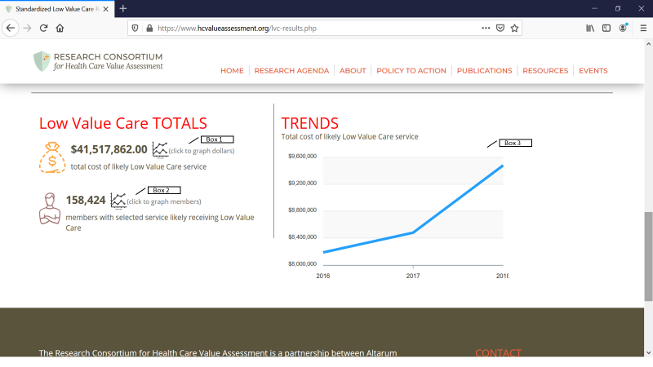

Summary
The Low-Value Care Visualizer is an easy-to-understand way to visualize the extent of low-value care that may be present in the user’s dataset. The Low-Value Care Visualizer does not require the use of a particular claims estimator, it can used with any process that has identified services as low-value. Contact the Consortium Manager for any questions or comments.

Appendix A – Short Identifiers and Long Descriptions
Short identifiers are used in the stacked bar chart on the Aggregate Results page. The following is a cross-walk of the short identifier and the long description.
Identifier | Distinct Low Value Care Service
LBP | Don't do imaging for low back pain within the first six weeks, unless red flags are present
Headache Images | Don't do imaging for uncomplicated headache
CT/MRI Syncope | Don't obtain brain imaging studies (CT or MRI) in the evaluation of simple syncope and a normal neurological examination
Allergy | Don't perform unproven diagnostic tests, such as immunoglobulin G (IgG) testing or an indiscriminate battery of immunoglobulin E (IgE) tests, in the evaluation of allergy
Urticaria | Don't routinely do diagnostic testing in patients with chronic urticaria
EEG Headaches | Don't perform electroencephalography (EEG) for headaches
Image Carotid Arteries | Don't perform imaging of the carotid arteries for simple syncope without other neurologic symptoms
CT Hearing Loss | Don't order computed tomography (CT) scan of the head/brain for sudden hearing loss
Imaging Rhinosinusitus | Don't routinely obtain radiographic imaging for patients who meet diagnostic criteria for uncomplicated acute rhinosinusitis
Calcium Scoring | Don't use coronary artery calcium scoring for patients with known coronary artery disease (including stents and bypass grafts)
CT Dizziness | Don't perform routine head CT scans for emergency room visits for severe dizziness.
Infertility | Don't perform advanced sperm function testing, such as sperm penetration or hemizona assays, in the initial evaluation of the infertile couple
PCT Infertility | Don't perform a postcoital test (PCT) for the evaluation of infertility
CT Kidney Stones | Don't order CT scans of the abdomen and pelvis in young otherwise healthy emergency department patients (age <50) with known histories of kidney stones, or ureterolithiasis, presenting with symptoms consistent with uncomplicated renal colic
Imaging Eye Disease | Don't routinely order imaging tests for patients without symptoms or signs of significant eye disease
Head CT Kids | Don't order computed tomography (CT) head imaging in children 1 month to 17 years of age unless indicated
Stress Cardiac Imaging | Don't perform stress cardiac imaging or advanced non-invasive imaging in the initial evaluation of patients without cardiac symptoms unless high-risk markers are present
Antibiotics Conjunctivitis | Don't order antibiotics for adenoviral conjunctivitis (pink eye)
Antibiotics Tube Otorrhea | Don't prescribe oral antibiotics for uncomplicated acute tympanostomy tube otorrhea
Cough/Cold Meds for Kids | Don't prescribe or recommend cough and cold medicines for respiratory illnesses in children under four years of age
Antibiotics URI | Don't prescribe oral antibiotics for members with upper URI or ear infection (acute sinusitis, URI, viral respiratory illness or acute otitis externa)
NSAIDS | Don't prescribe nonsteroidal anti-inflammatory drugs (NSAIDS) in individuals with hypertension or heart failure or CKD of all causes, including diabetes
Unwarranted C-Sections | Don't schedule elective, non-medical indicated inductions of labor or Cesarean deliveries before 39 weeks, 0 days gestational age
Arthroscopic Knee Surgery | Don't perform an arthroscopic knee surgery for knee osteoarthritis
Antidepressants | Don't prescribe antidepressants as monotherapy in patients with bipolar I disorder
CT Routine Abdomen | Don't perform Computed tomography (CT) scans in the routine evaluation of abdominal pain
Revascularization | Don't perform revascularization without prior medical management for renal artery stenosis
Vertebrolplasty | Don't perform vertebrolplasty for osteoporotic vertebral fractures
PICC | Don't place peripherally inserted central catheters (PICC) in stage III-V CKD patients without consulting nephrology
Palliative Radiation | Don't recommend more than a single fraction of palliative radiation for uncomplicated painful bone metastasis
CBC | Don't obtain baseline laboratory studies in patients without significate systemic disease (ASA I or II) undergoing low-risk surgery - specifically complete blood count, basic or comprehensive metabolic panel, coagulation studies when blood loss (or fluid shifts) is/are expected to be minimal
Pre-Op Cardiac | Don't obtain baseline diagnostic cardiac testing (trans-thoracic/esophageal echocardiography - TTE/TEE) or cardiac stress testing in asymptomatic stable patients with known cardiac disease (e.g. CAD, valvular disease) undergoing low or morderate risk non-cardiac surgery
Pre-Op LRS | Don't obtain EKG, chest X rays or Pulmonary function test in patients without significant systemic disease (ASA I or II) undergoing low-risk surgery
Arthritis | Don't perform MRI of the peripheral joints to routinely monitor inflammatory arthritis
PSA | Don't perform PSA-based screening for prostate cancer in all men regardless of age
Colorectal | Don't order unnecessary screening for colorectal cancer in adults oder than age 50 years
DEXA | Don't use dual-energy x-ray absorptiometry (DEXA) screening for osteoporosis in women younger than 65 or men younger than 70 with no risk factors
EKGs | Don't order annual elctrocardiograms (EKGs) or any other cardiac screening for low-risk patients without symptoms
Vitamin D | Don't perform population based screening for 25-OH-Vitamin D deficiency
Coronary Angiograph | Don't perform coronary angiography in patients without cardiac symptoms unless high-risk markers present
PAP/HPV | Don't order unnecessary cervical cancer screening (Pap smear and HPV test) in all women who have had adequate prior screening and are not otherwise at high risk for cervical cancer

